Parts of Vertebrates

MATERIALS: Standard format for classified nomenclature.
- folder (pictures – oral terminology, name slips – word reading, definition cards – sentence reading)
- Booklet

Printable material can be purchased here. (See images after lesson for how to store.)

Five classes to study: Fish, Amphibian, Reptile, Bird, Mammal

PRESENTATION #1: Parts of a fish
- Do an in-depth observation of a live fish with the children (if you don’t have a fish at home, you can visit an aquarium or pet store where they sell fish).
- Discuss the fish’s appearance, behavior, environment, and how the fish differs from us.
- Discuss the parts of the fish and what they are used for. Give the names of the parts in the context of your conversation. Include etymology whenever relevant.
- Invite them to look at the classified nomenclature.
- Point out that the fish on the card is not necessarily the same type of fish as the one the group just observed. Point out any relevant differences (like size and environment – salt water vs. fresh water).
- Lay out the cards in a row (first the whole fish, followed by all the parts).
- Go through the names of the parts again, asking the children if they can recall the names of any parts.
- Invite the children to read the slips and match them to the pictures. Invite them to check their work with the control booklet.
- Then, they can put the pictures in the same order as the control booklet.
- Finally, invite the children to read the cards and you can read the control booklet (as a way of encouraging the children to read the cards one more time).
- Give each child a definition card and invite each to read his card out loud and match it to the relevant picture. If the child can’t read sentences yet, the adult can read the sentences for the child and the child can match to the part of the animal.
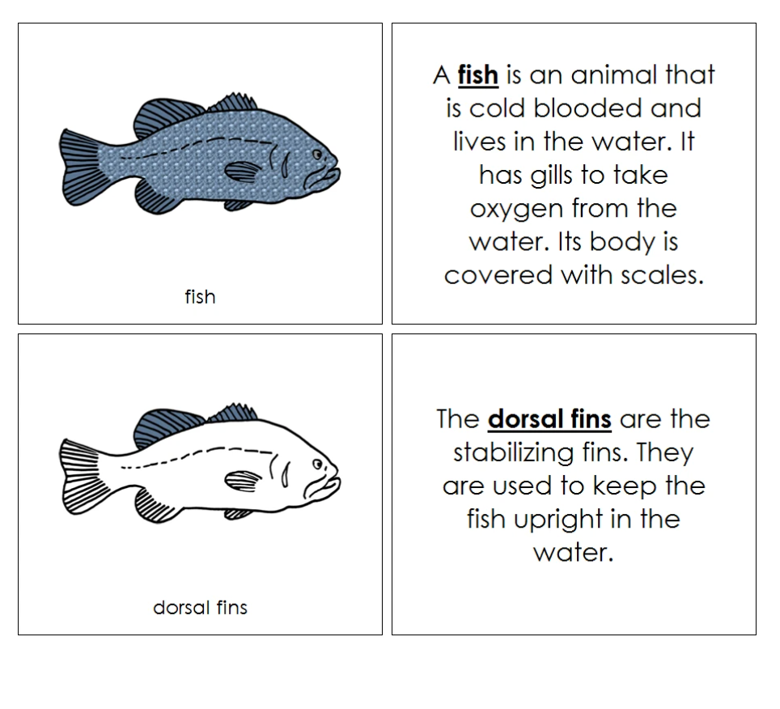
Image: Montessori Print Shop

→ Present all other vertebrates the same way, making sure the child gets to observe a real specimen prior to the lesson whenever possible.

Here’s an example of the Parts of the Horse, for word-reading work. I handmade the pouch from an 8.5x11 piece of felt. You can also make the pouch out of cardstock. The booklet has complete sentences. You can get books spiral-bound at office supply stores.

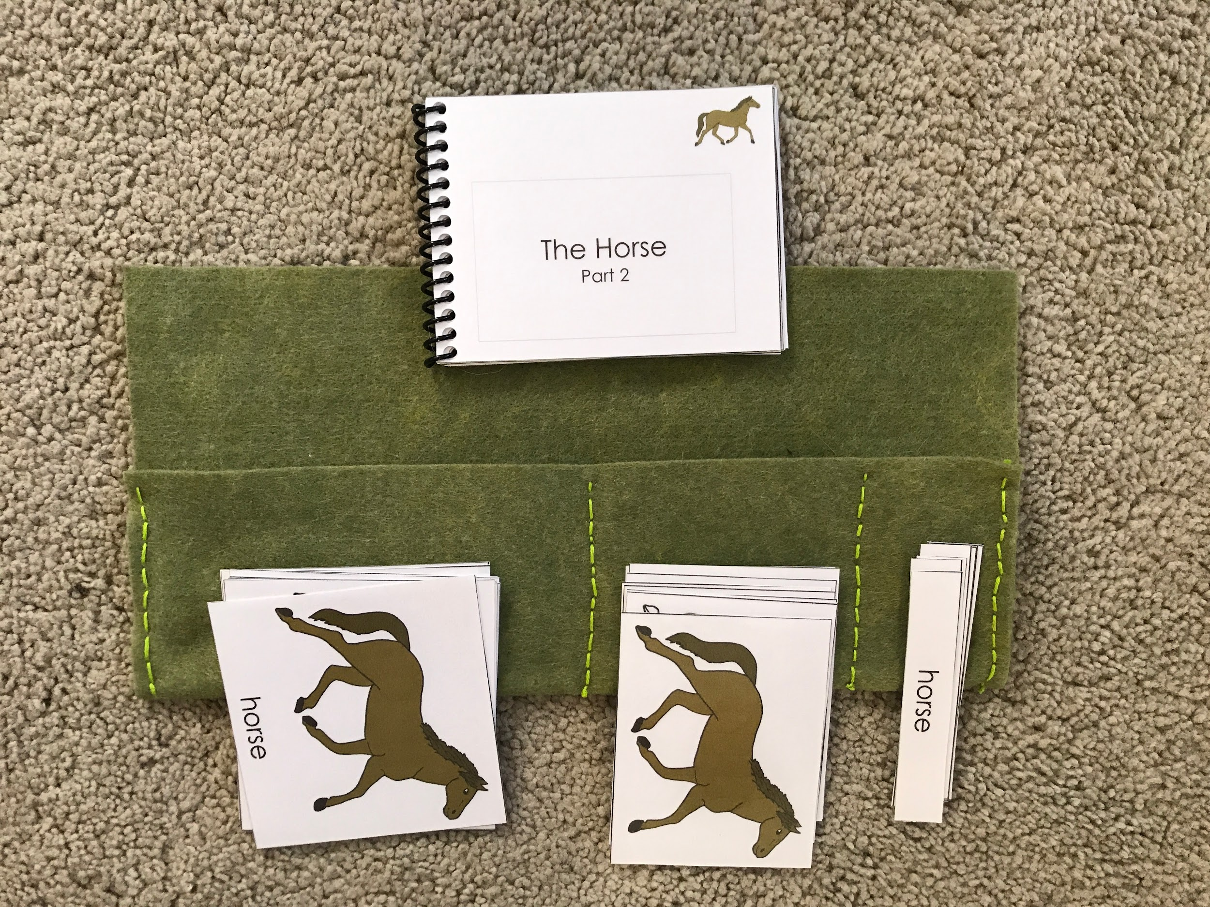

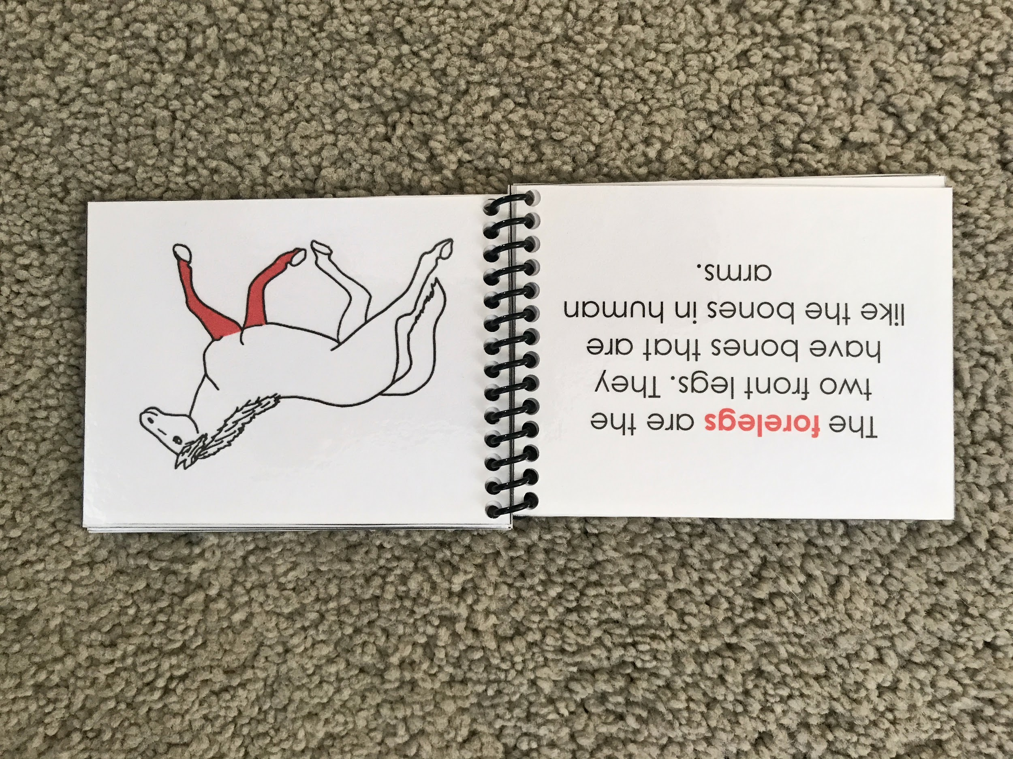

Follow-up activities: Drawing, painting, sculpting the animal the child is studying, and writing labels for its parts. The child can make their own booklet either by tracing or by drawing freehand.

